February 26, 2024

SUBJECT: H0 404 Amends existing law to provide an exemption from disclosure for certain records regarding wildlife.

Dear Senator Burtenshaw,

Idaho Business for the Outdoors supports the passage of House Bill 404. This legislation would allow government agencies, including the Idaho Department of Fish and Game (IDFG), to deny public record requests of specific wildlife animal locations. We believe that this bill protects the right to a fair hunt.

Idaho Business for the Outdoors is a business member-based organization. Our mission is to provide a collective, non-partisan business voice that advocates for healthy lands, open space, and swimmable, fishable, and drinkable waterways. We value the wellness benefits that Idaho's outdoors provides for our businesses, our workers, and all Idahoans. Idaho Business for the Outdoors recognizes the role hunting plays for many in Idaho as not only a wildlife management tool but also as an important part of Idaho’s lifestyle.

Our membership is made up of industries and businesses of all sizes including some of the largest employers in Idaho. Open space, healthy lands, and waters promote investments, innovations, jobs, enhance revenues, and provide wellness benefits. These are sustained through the preservation of Idaho's outdoors and waters. H0404 aligns with our mission and our values and guarantees the fair-chase rules remain in Idaho for fishing and hunting. Please share our support with other sponsors in the Senate and other legislators as you see fit.

Best Regards,
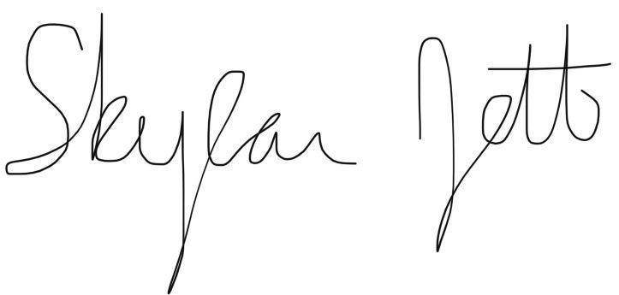
Skylar Jett, Executive Director, Idaho Business for the Outdoors

